Concentrations, loads, and associated trends of nutrients entering the Sacramento-San Joaquin Delta, California

By Dina Saleh, Tamara Kraus, and Brian Bergamaschi

# **ABSTRACT**

Statistical modeling of water quality monitoring data collected at the Sacramento River at Freeport and San Joaquin River near Vernalis, California, USA were used to examine trends in concentrations and loads of various forms of dissolved and particulate nitrogen and phosphorus entering the Sacramento-San Joaquin River Delta (Delta) from upstream sources between 1970 and 2019. These two locations represent the predominant supply of freshwater input to the Delta. Planned upgrades to Sacramento’s regional wastewater treatment facility, located just below the Sacramento River sampling location, will significantly reduce inorganic nitrogen, especially ammonium inputs to the northern Delta, thus the supply of bioavailable nitrogen throughout the estuary will diminish, resulting in a potential shift from phosphorus to nitrogen as a limiting nutrient in some regions of the Delta, especially the north Delta. Ammonium concentrations and loads decreased at both of these locations from the mid-1970’s to 2019. At both sites, current ammonium concentrations are mostly below 4 μM, a concentration above which reductions in phytoplankton productivity or changes in algal species composition may occur. Nitrate concentrations and loading differed at both locations. At the Sacramento River location, nitrate concentrations decrease in the summer agricultural season resulting in reductions in molar ratios of nitrogen to phosphorus. In contrast, nitrate concentrations increase in the San Joaquin River during the agricultural season as a result of irrigation runoff increasing the molar ratio of nitrogen to phosphorus. These contrasting processes will result in a nitrogen limited system in the north Delta and a phosphorus limiting system in the south. Source modeling of nitrogen and phosphorus indicate that agriculture and atmospheric deposition are the two major sources of nitrate in the Central Valley and geologic sources, agriculture, and wastewater discharge as the main sources of phosphorus.

# **INTODUCTION**

The Sacramento-San Joaquin Delta (hereafter referred to as the Delta) is part of the largest estuary on the west coast of North America covering an area of about 2,984 km2. The Delta is also a point of transfer of freshwater to cities and agricultural regions (Templin and Cherry, 1997, Saleh and Domagalski, 2015). About 2,024 km2 of the Delta is agricultural land and home to large number of species of birds, mammals, and fish (CA. Gov Delta Protection Commission, 2012). The Delta receives most of its freshwater input from the combined flows of the Sacramento and San Joaquin Rivers which collectively drain 100,000 km2 of land. Water management for flow and water quality require that numerous decisions need to be made, many of them daily, regarding reservoir releases, diversions, aquatic species management, and environmental flows to protect water quality (Luoma et al., 2015).

In recent years, the forms of nutrients and nutrient stoichiometry, especially the relative amounts of ammonium versus nitrate but also nitrogen versus phosphorus, have been suggested as causing changes in primary productivity –particularly the abuandance and species composition of phytoplankton –which may affect food webs in the Delta (Glibert, 2010, Parker, et al., 2012). The potential effects on the ecosystem from ammonium in wastewater discharge prompted the California Central Valley Water Quality Control Board to issue new discharge requirements for one of the largest dischargers of wastewater to the Delta, the Sacramento County Regional Sanitation District, hereafter referred to as Regional San (<https://www.regionalsan.com/echowater-project>). Mandated upgrades to the Regional San facility include biological nutrient removal which will remove most of the ammonium via nitrification, and a portion of the nitrate via denitrication. In addition, the upgrades may result in some phosphorus removal (Yost, 2011), although those are expected to be minor. These upgrades are expected to significantly decrease nutrients load to the Delta to about 99% annual decrease in ammonium, and 75% annual decrease in dissolved inorganic nitrogen, mainly nitrate (Krich-Brinton et al., 2012, Krich-Briton, 2017; Senn et al. in prep). The treatment plant upgrades will result in a substantial decrease in the amount of nitrogen entering the Delta and may in itself result in ecosystem changes (<https://www.regionalsan.com/echowater-project>). Other treatment plants that discharge to the Delta waters are also upgrading their facilities or management of their effluents. These include the Modesto Water Quality Control facility, the Turlock Regional Water Quality Control facility and the Stockton Regional Wastewater Control facility (figure 1).

Once these upgrades are operational, there will be a change in the amount of inorganic nitrogen entering the Delta. Ongoing research is attempting to understand how these changes may affect the Delta ecosystem (Richey et al., 2018; Senn et al. in prep). To better understand the future effects of these planed changes on nutrient availability and transport to the Delta, historical nutrient loads and trends in the Sacramento and San Joaquin Rivers upstream of these Delta facilities were evaluated as the upstream sources provide a large load of the nitrogen and phosphorus in various forms. Understanding these sources of nutrients and their forms may be useful for future management decisions on ecosystem management of the Delta. A multi-year record of monitoring data (1970-2019) is available for the various forms of nitrogen and phosphorus at two locations, the Sacramento River at Freeport and San Joaquin River near Vernalis (figure 1). These two rivers provide most of the freshwater to the Delta and drain large watersheds with complex land uses including agriculture, urban, and natural. Information from these two sites and the upstream watersheds were used to evaluate historical nutrients sources, the upstream spatial distribution of nutrient sources throughout the watersheds, and transport of nutrients to the Delta along the river courses. The long-term record of discrete data collection was supplemented with a smaller record of high frequency (15-minute) monitoring data for nitrate at the Sacramento River at Freeport site (2014 to 2019). The longer record of discrete sampling captures various weather conditions including wet years (1997, 2017) and drought years (2012-2016). Trend estimation was completed for Kjeldahl nitrogen, nitrite plus nitrate (NO2 and NO3) hereafter referred to as nitrate because of mostly low concentrations of nitrite, ammonium(NH4), total nitrogen (TN) orthophosphate (OP) and total phosphorus (TP) allowing managers to understand the watershed contribution of various forms of bioavailable nutrients, as these enter the Delta and provide the nutrients for aquatic food webs.

Nutrient trends within the estuary and the inflow streams to the Delta have been reported on by Beck et al. (2018), and Schlegel and Domagalski (2015) and others. Beck et al. (2018) discussed trends in nitrate, ammonium and silica at the two sites of this study and within the estuary up to the time period of 2013. Schlegel and Domagalski (2015) also discussed trends up to 2013 for total nitrogen, ammonium, nitrate, and total phosphorus for the two sites of this study and for upstream sites in both the Sacramento and San Joaquin Rivers. This study expands on the previous investigations of the sites above the wastewater treatment facilities by extending the study period to 2019, by including the previously modeled nutrients and bioavailable orthophosphate, and an examination of upstream watershed sources of total nitrogen and total phosphorus.

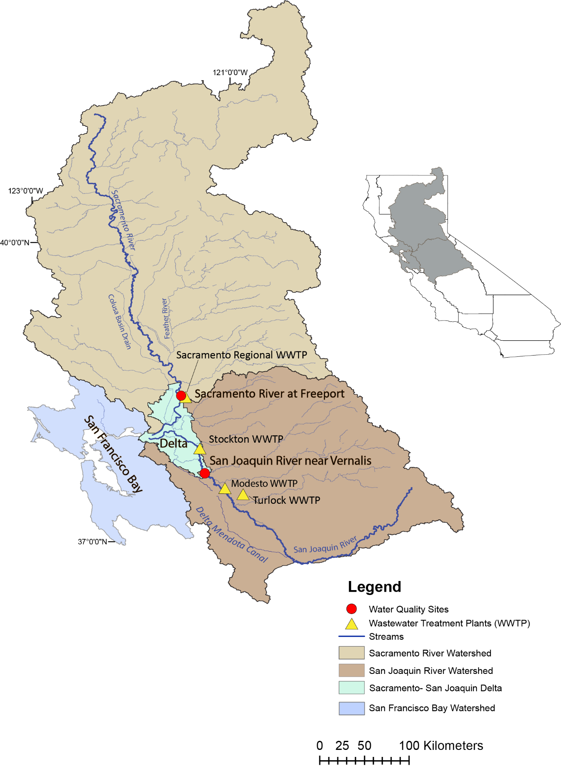

**Figure 1.** Location of the two sampling sites, geographic extent of the Sacramento and San Joaquin River watersheds and Sacramento-San Joaquin Delta and locations of selected wastewater treatment plants.

# **STUDY AREA AND DATA SOURCES**

The San Francisco Bay Delta system is the largest estuary on the west coast of North America consisting of about 4,160 km2 of which the Delta makes up about 2,984 km2. The Sacramento and San Joaquin Rivers deliver freshwater to the Delta with annual inputs of about 84% coming from the Sacramento River, 13% coming from the San Joaquin River, and 3% from other smaller rivers (Jassby and Cloern, 2000, Saleh and Domagalski, 2015). The Sacramento and San Joaquin Rivers are the two largest rivers in California delivering an average of 650 m3/s and 120 m3/s of water respectfully to the Delta annually. Both river systems contain many upstream diversions and impoundments designed to provide flood protection and to ensure a reliable drinking water and irrigation water supply to over 2 million Californians (Kratzer at al., 2011). Nutrients enter the Delta primarily through the Sacramento and San Joaquin Rivers and from municipal wastewater treatment plant (WWTP) inputs. Regional San’s effluent is discharged to the Sacramento River 0.18 river kilometers downstream from the USGS monitoring site at Freeport (figure 1). The treatment plant collects wastewater from approximately 1.4 million customers and was designed to release about 116 million gallons per Day (MGD) of secondary treated effluent to the Sacramento River, with nutrient loadings averaging about 13,594 kg/day of ammonium, 14,818 kg/day total nitrogen (TN), and 999 kg/day total phosphorus (TP) (Yost, 2011). The Stockton WWTP is located about 40 river kilometers downstream from the Vernalis site. Stockton WWTP was designed to release about 23 MGD of tertiary treated effluent with nitrification effluent to the San Joaquin River, with lower nutrient concentrations averaging about 114 kg/day ammonium, 1,579 kg/day total nitrogen (TN), and 90 kg/day total phosphorus (TP) (Yost, 2011).

Concentration data for nitrate, ammonium, Kjeldahl nitrogen, orthophosphate, total phosphorus, and total nitrogen (total nitrogen is the sum of nitrate and Kjeldahl Nitrogen) for the study were obtained from various sampling programs at two USGS stream gauge locations, Sacramento River at Freeport (11447650) and the San Joaquin River near Vernalis (11303500) over the 1970-2019 period. All the discharge data and most of the water quality data were obtained from U.S. Geological Survey National Water Inventory System (NWIS; <https://waterdata.usgs.gov/nwis>); other additional water quality data were obtained from a previously published report (Kratzer et al., 2011). These two sites selected for this study were sampled frequently (have more than 200 samples) over the 1970-2019 period and have a continual record of streamflow data concurrent with the water quality records at these sites.

# **METHODS**

Discharge measurement methods are described by Turnipseed and Sauer (2010)and Sauer and Turnipseed (2010). Measurements of stream stage are collected every 15 minutes, and then converted to discharge using rating curves (ref). Instantaneous velocity measurements are collected periodically to verify and recalibrate the rating curves. Nutrients were analyzed at the U.S. Geological Survey laboratory as described by Fishman, et. al., 1993. The period of record for this analysis was 1970 to 2019. Concentrations, mass loads, and trends were estimated using the Weighted Regressions on Time, Discharge, and Season (WRTDS) model (Hirsch et al. 2010). Watershed sources of nutrients (total Nitrogen and total Phosphorus) were assessed using the SPAtially Referenced Regressions On Watershed attributes (SPARROW) models (Preston et al., 2009, 2011b).

The WRTDS model is written in the R computing framework and is publicly available from the Comprehensive R Archive Network (<https://www.R-project.org>). The model was developed to produce estimates of concentration and load, along with the ability to calculate flow-normalized estimates of concentration and loadwith graphical capabilities to illustrate the resulting trends. Estimated concentrations and fluxes for nitrogen forms--(nitrate (NO3), ammonium (NH4), total Kjeldahl nitrogen (TKN), orthophosphate (OP), and total phosphorus (TP)--over the 1970-2019 period were estimated using the WRTDS model for the Sacramento River at Freeport and the San Joaquin River near Vernalis. WRTDS evaluates a concentration-discharge relationship based on time, discharge and season by re-evaluating coefficients for each day of estimation. The estimated concentration is a product of the following equation:

In(*Cij*)=*β0*+ *β1Tij* + *β2* In(*Qij*)+ *β*3 sin(2π*Tij*) + *β*4 cos(2π*Tij*) + ε*ij*  (1)

Where for a specific day *i* and year *j*:

*C*; is the concentration (in mg/L), *Q*; is the mean daily discharge (in m3/s), T; is the time in decimal years, β; are fitted coefficients, and ε is the unexplained variation (Hirsch et al. 2010). Statistical significance of the calculated loads is given by a flux bias statistic. Most of those indicated a favorable model with a bias statistic of plus or minus 1 to 10%. Estimates of concentration and load can be presented on a daily to annual time scale. Further information about how concentrations and loads change with time is provided by a flow normalization calculation. Within an annual time period, there are variations in streamflow measurements at any given site over the period of the record, which may be natural, such as flood and drought cycles, or through water management. To deal with discharge variations the Flow-Normalized-Concentrations (FNC) approach is used in WRTDS (Hirsch et al. 2010). The FNC for day *i* and year *j* is defined as (equation 2):

$C_{ij}= \int_{0}^{∞}{w\left(Q, T_{ij}\right).g_{ij}\left(Q\right)dQ}$ (2)

Where: C*ij* is the flow-normalized-concentration for day *i* and year *j*, g*ij*(Q) is the probability density function of discharge (Q) for day *i* of year *j*, and w(Q,Tij) is a smooth continuous function of two variables, discharge (Q) in m3/s, and time (T) value for day *i* and year *j*. WRTDS uses weighted regression approach to estimate *w*, g(Q) is estimated with the flow-normalization approach with the assumption that discharge is stationary for any day *i* in a year *j* over the period of record (Hirsch et al. 2010).

Trends in concentration or load, and their significance levels, were calculated using the EGRETci R-package. The EGRETci R-package uses a bootstrap method and an adaptive Bayesian approach to evaluate when to accept or reject the null hypotheses (Hirsch et al., 2015). An  value of 0.1 is used in order to increase the power to detect a real trend. A term, denoted as *f* , is the fraction of bootstrap replicates, in an infinite number of bootstrap replicates, for which the estimated change in flow normalized flux is positive. An estimate can be made at any stage of the bootstrap process denoted as ̂*f*. That term is defined as the mean of the Bayesian posterior distribution of *f*. A full description is given in Hirsch et al., 2015. Definitions for determining the statistical significance of a trend direction, given by the function of ̂, are given in Table 1. The EGRETci method applies a bootstrapping test using Monte Carlo simulations to estimate the probability of detecting a trend. The model runs 100 bootstrapping test iterations over a 200-day bootstrapping window for the period of record. Output from the EGRETci test includes a p-value statistics, however trend uncertainty is expressed in terms of an estimate of trend likelihood representing the probability of increasing or decreasing of trends (Hirsch et al. 2015). The trend likelihood terminology is divided into 3 categories (Table 1). Within any trend direction; a “Highly Likely” trend would mean that at there is at least 95 out of a 100 chance that there is a trend in that direction, a “Very Likely” trend means that there are 90 to 95 chances of a 100 that the trend would be in a specific direction, and finally a “Likely” trend would mean that there is a 90 to 66 chances of a 100 that there is a trend in a that direction. Along with the likelihood and the direction of trend for each constituent, EGRETci output also provides an estimated change value for concentrations and loads in mg/L and kg/year respectively.

***Table 1.*** *Definitions for descriptive statements of trend likelihoods for WRTDS Bootstrap test as a function of ̂, the posterior mean estimate of the probability of an increasing trend (Hirsch et al., 2015).*

|  |  |
| --- | --- |
| **Range of ̂ Values** | **Descriptors** |
| ≥ 0.95 and ≤ 1.0 | Highly Likely |
| ≥ 0.9 and < 0.95 | Very Likely |
| ≥ 0.66 and <0.90 | Likely |
| > 0.33 and < 0.66 | About as Likely as Not |
| > 0.1 and ≤ 0.33 | Unlikely |
| > 0.05 and ≤ 0.1 | Very Unlikely |
| ≥ 0 and ≤ 0.05 | Highly Unlikely |

Trends in daily streamflow were completed using a non-parametric Mann Kendall approach using various R packages (<https://www.R-project.org>, <https://owi.usgs.gov/blog/Quantile-Kendall/>). Statistics were compiled for 7-day minimum, 7-day maximum, median daily, and mean daily measurements. Statistical results were compiled across the range of non-exceedance probabilities.

The SPARROW model (Preston et al., 2009, 2011b) uses a hybrid statistical and process-based approach that relates nutrient loads to upstream sources, and watershed characteristics using a nonlinear least squares (NLLS) multiple regression. This was used to identify sources and estimate loads of total nitrogen and total phosphorus to the Sacramento and San Joaquin Rivers. SPARROW includes nonconservative transport, mass-balance constraints, and water flow paths referenced to the digital a stream network, National Hydrography Dataset Plus (NHD-Plus) Version 2 (http://www.horizon-systems.com/NHDPlus/NHDPlusV2_home.php), which defines topography, streams characteristics, and reservoirs inputs for the SPARROW model. Potential sources of nutrients to streams throughout the modeled watersheds such as atmospheric deposition, fertilizer use, geologic sources, wastewater treatment, amounts of land in different use categories, and other potential variables were based on data for 2012. Discharge used to model the movement of total nitrogen and total phosphorus from sources to streams was normalized to 2012 by a de-trending procedure. The SPARROW model includes three types of parameters to provide a prediction on fluxes leaving catchments: sources, land-to-water delivery variables, and instream loss. Water-quality predictors in the model are developed as functions of both reach and land surface attributes and include quantities describing contaminant sources (point and nonpoint) as well as factors associated with rates of material transport through the watershed. Details on the theoretical development of the SPARROW model are provided by Alexander et al. (2008) and Schwarz et al. (2006).

High frequency nitrate concentrations were measured at the Sacramento River at Freeport site using automated submersible ultra-violet nitrate sensors (SUNA, Version 2; Satlantic, NS, Canada), which measures both nitrate and nitrite. Manufacturer stated precision for these 10 mm path length instruments is 0.3 μM (0.004 mg N/L) and accuracy is 2 μM (0.028 mg N/L). Further details are given by Kraus et al. (2017). Nitrate concentrations measured with the sensor were compared with 100 discrete measurements collected at the same location. The sensor measurement corresponding to the time of the discrete sample was used for the comparison. There was a good linear correlation between sensor and laboratory measurements (y = 0.809x – 0.034,r2 = 0.94). The sensor data were biased slightly higher than the laboratory data, thus sensor results shown in this report were corrected using the regression shown in the previous sentence.

# **RESULTS**

## **Streamflow Tends**

Statistical analyses were used to evaluate trends in daily discharge over the 1970-2019 period for the Sacramento River at Freeport and the San Joaquin River near Vernalis. There is a decreasing trend in all four annual statistics (minimum daily, median daily, maximum daily, and mean daily) for both sites (figure 2, and figure 3). However, these trends are only statistically significant for annual minimum daily discharges at the Sacramento River at Freeport with a p-value of 0.033 and a decreasing slope of 0.64% per year. This is also reflected in the Quantile-Kendall plot (figure 4). The plot shows that at the Sacramento River at Freeport there was no statistically significant trend in all parts of the flow duration curve over the 365 days of the year (Figure 4A). On the other hand, at the San Joaquin River near Vernalis there were substantial (Very likely) negative trends at the medium (50% and 75%) quartile of the flow duration curve (figure 4B) (Hirsch, 2015).

Discharge measurements at the Sacramento River at Freeport and the San Joaquin River near Vernalis vary year to year and are consistent with variable weather condition during the 1970-2019 period. During a high-water year, such as 1997, maximum discharge measurement at the Sacramento River at Freeport and the San Joaquin River near Vernalis reached 3,200 m3/s, and 1,537 m3/s respectively. Discharge was much lower in drought years, such as 2012-2016 (Western Regional Climate Center <http://www.wrcc.dri.edu/cg-bin/cliMONtpre.pl?ca7630>) where average measured mean daily discharge at the two sites was about 175 m3/s at Sacramento River at Freeport, and about 9 m3/s at San Joaquin river near Vernalis.

**Figure 2.** Annual discharge (streamflow) trends for the Sacramento River at Freeport from 1970 to 2019 for four annual discharge statistics: annual minimum day, maximum day, median daily and mean daily. The statistics are determined from the daily discharge record for the stream gauge for the period of record of this study. Each panel shows a Thiel-Sen slope estimate expressed in percentage change per year, and a two-sided p-value for the Mann-Kendall trend test.

**Figure 3.** Discharge (streamflow) trends for the San Joaquin River near Vernalis from 1970 to 2019 for four annual discharge statistics: annual minimum day, maximum day, median daily and mean daily. The statistics are determined from the daily discharge record for the stream gauge for the period of record of this study. Each panel shows a Thiel-Sen slope estimate expressed in percentage change per year, and a two-sided p-value for the Mann-Kendall trend test.

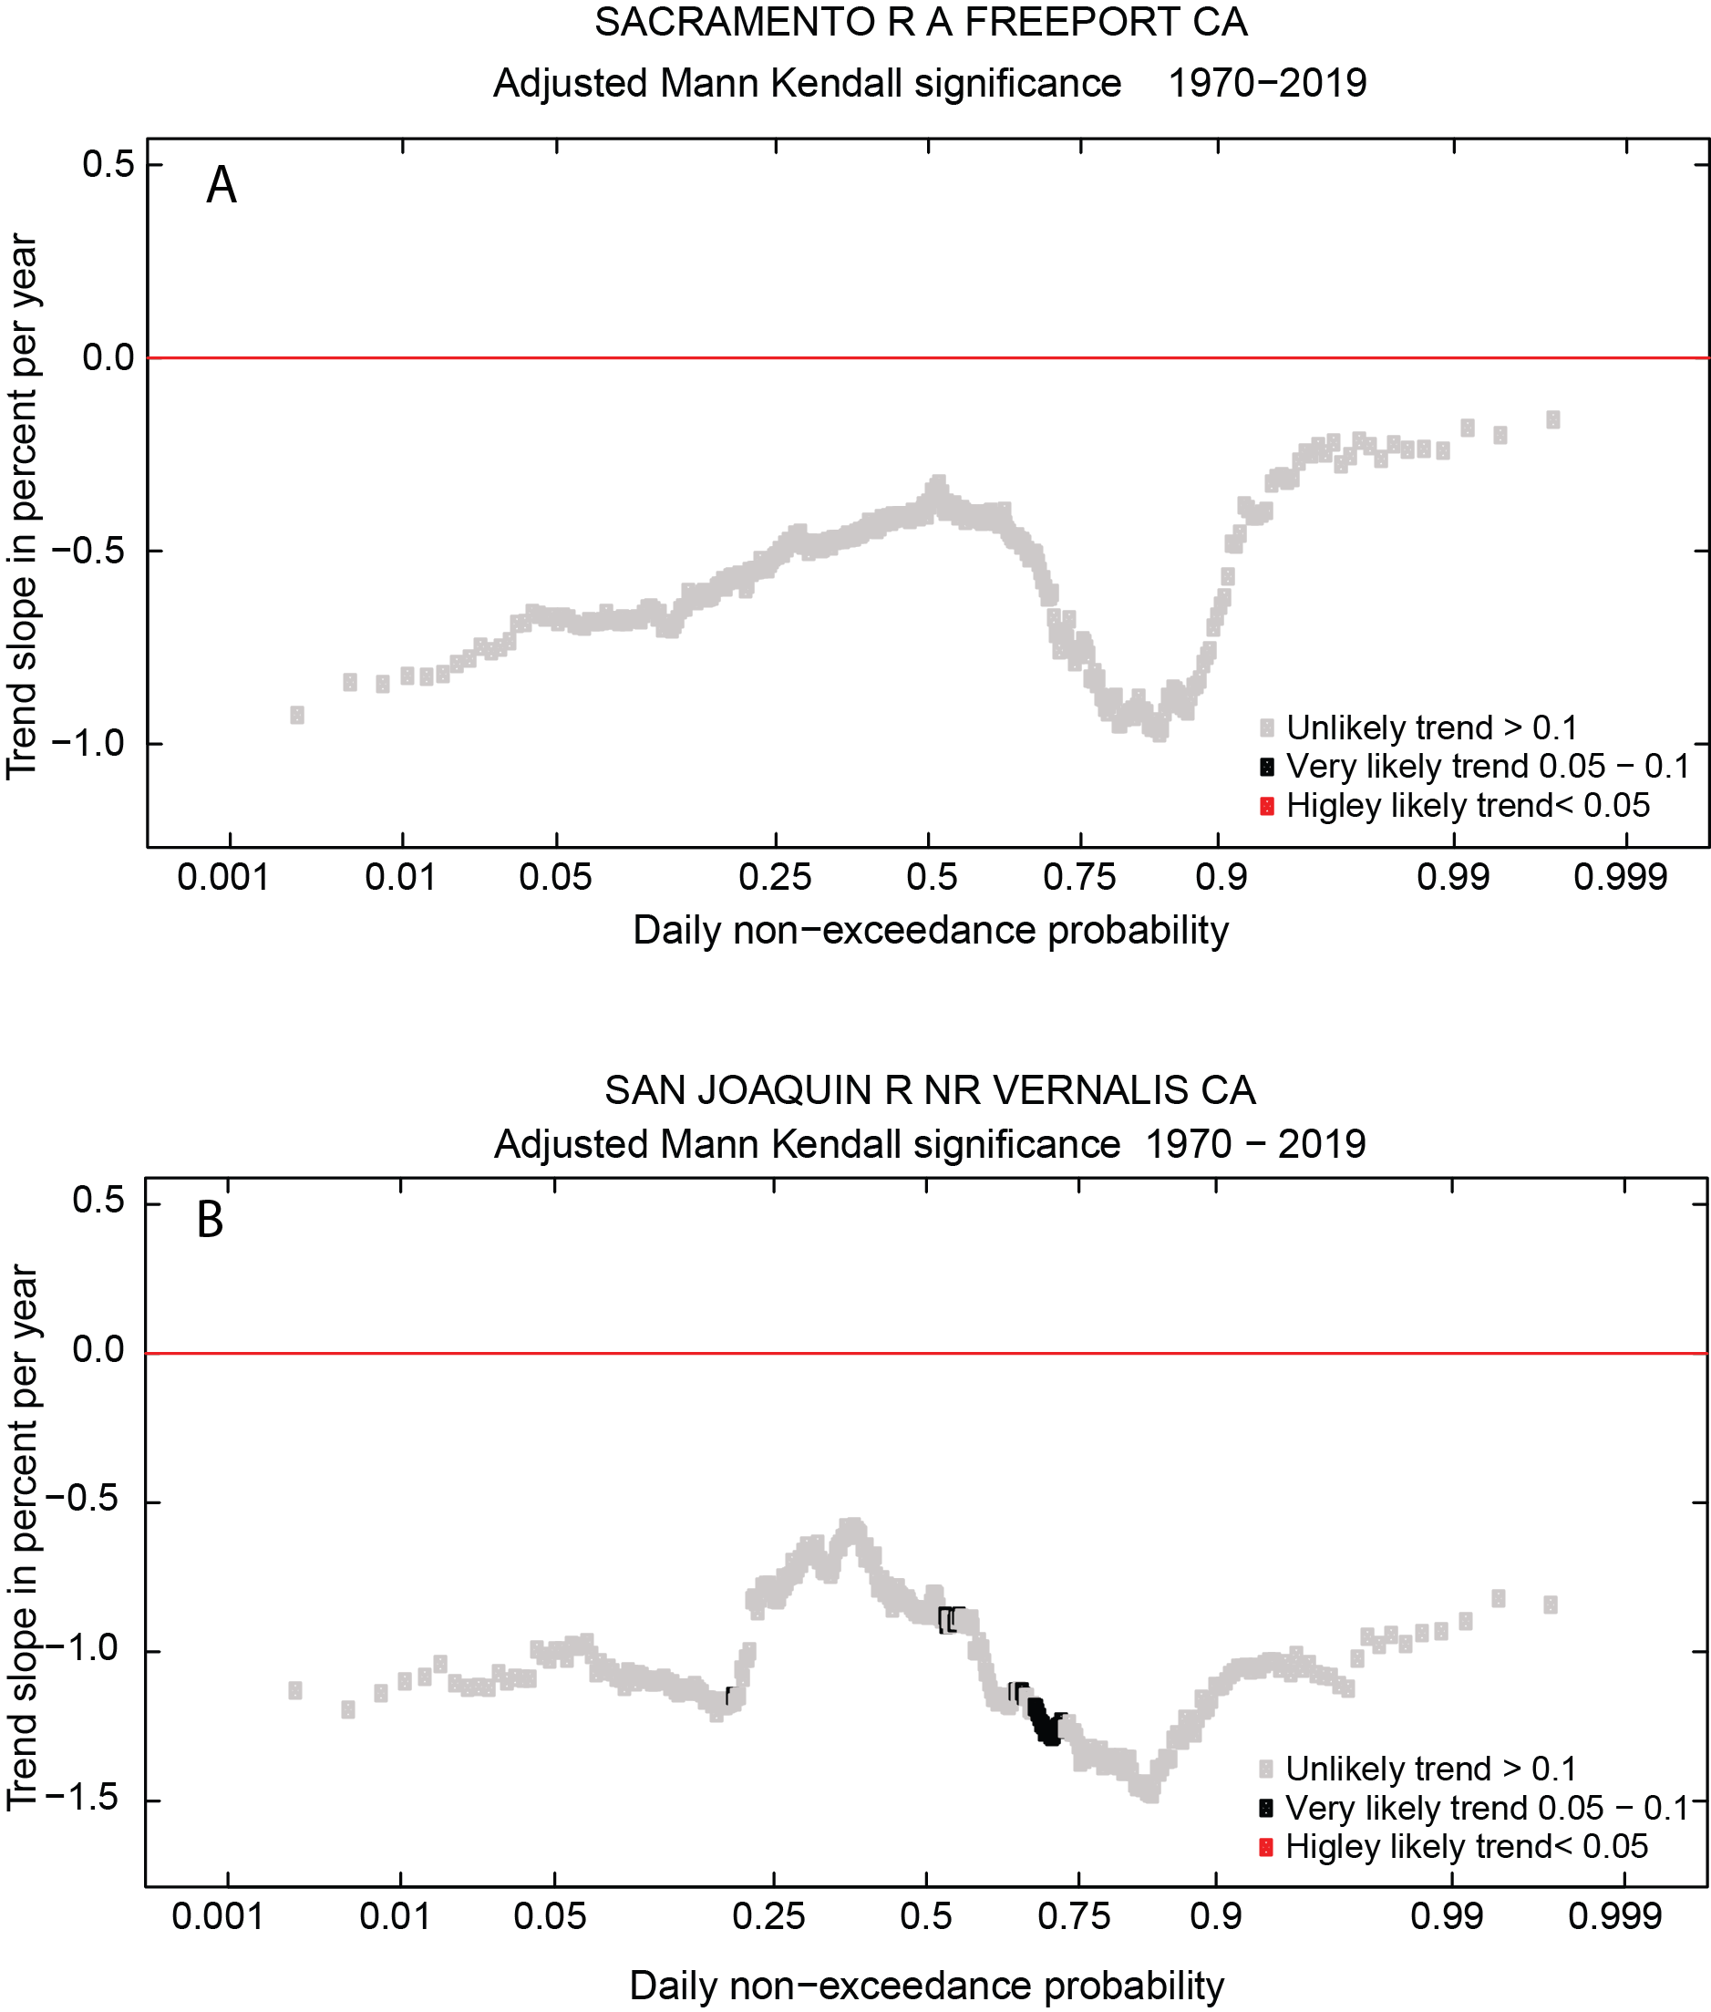

**Figure 4**. Quantile-Kendall plot showing 1970 to 2019 trends in discharge at A) Sacramento River at Freeport and (B) San Joaquin River near Vernalis. Daily discharge values were ranked from 1 (the lowest rank) to 365 (the highest rank) within each year. Each point represents the estimated trend slope (expressed in percent change per year) for mean daily discharge values of the given rank (1 through 365). Low-flow trends are at the left and high-flow trends are at the right. Colors indicate, for each rank, the likelihood of the estimated trend slope.

## **Sacramento River at Freeport, Nutrient Concentrations, Loads, and Trends**

Modeled concentrations and loads for the Sacramento River at Freeport are shown in Figure 5. On these and other similar plots, average annual concentrations and annual loads from the model are shown as dots. The flow normalized concentration and load are shown as a continuous fitted line. Confidence intervals are calculated for the flow normalized trends. Flow-normalized nitrate concentrations and loads follow a similar pattern throughout the 1970-2019 period (figure 5A, and 5B). Flow-normalized concentrations and loads of nitrate increase in the earlier time period (1975 to 1983) followed by a slight decrease after 1983. Flow-normalized concentrations increased slightly in late 1980s and nitrate concentrations and loads reach their highest estimates in 1988 (0.15 mg-N/L, and 3.15 million kg-N/Year respectively). Flow-normalized concentrations declined in the early 1990s and remained stable throughout the mid-1990s and early 2000s and then decreased slightly during the 2013-2015 drought period. Confidence intervals for the flow normalized concentration and load are also shown (figure 5A, and 5B). There is a weak “likely” increase in flow-normalized concentration (about 0.02 mg-N/L) and loads (about 0.48 million kg-N/Year) over the 1970-2019 period (Table 2). A Mann-Whitney-Wilcoxon Rank Sum test was used to compare flow-normalized nitrate concentrations between the early decade 1975-1985 and the recent decade 2009-2019 on a monthly time scale (figure 6A). In the early decade nitrate concentrations were highest in the winter months compared to the spring summer and fall. In contrast in the recent decade, nitrate concentrations were low in the winter and increased during the summer reaching its highest value in June. Nitrate concentrations will increase in winter storms, but dilution drives lower concentrations. The median nitrate concentrations between the early and recent decade are significantly decreasing in the winter (October through March) and significantly increasing during the summer months (May through August; Figure 6C). Median concentration difference between the early and recent decade are not significant in the months of April and September. This is shown in Figure 6C, where the vertical line crosses the 90% confidence for the median concentration difference between the two decades.

***Table 2.*** *Trend direction and significance of trends for flow normalized concentration and load at all sites and for all constituents for their respective periods of record. [NO3 CONC nitrate concentration; NH4 CONC, ammonium concentration; OP CONC, orthophosphate concentration; TKN CONC, Kjeldahl nitrogen concentration; TP CONC, total phosphorus concentration.* ***Cell colors as shown in Table 1****.*

|  |  |  |  |  |  |  |  |  |  |  |
| --- | --- | --- | --- | --- | --- | --- | --- | --- | --- | --- |
| Site name | NO3  CONC mg-N/L | NO3  Load kg-N/yr | NH4  CONC mg-N /L | NH4  Load kg-N /yr | TKN  CONC m-N g/L | TKN  Load kg-N /yr | OP  CONC mg-P/L | OP  Load kg-P/yr | TP  CONC mg-P/L | TP  Load kg-P/yr |
| Sacramento River at Freeport | Up  0.02 | Up  0.48 | Down  -0.17 | Down  -2.45 | Down  -0.26 | Down  -4.08 | Down  -0.04 | Down  -0.57 | Down  -0.09 | Down  -1.54 |
| San Joaquin River at Vernalis | Down  -0.14 | Down  -0.27 | Down  -0.11 | Down  -0.26 | Down  -0.78 | Down  -2.86 | Down  -0.01 | Down  -0.05 | Down  -0.09 | Down  -0.16 |

Estimated annual concentrations and loads for ammonium show a different pattern than that of nitrate (Figures 5C and 5D). There is a rapid decline in both concentration and load during the initial modeling period (in 1979, with the highest of concentration and load estimated at 0.2 mg-N/L, and 2.7 million kg-N/year respectively) followed by a continuous gradual decline in concentration and load to 2019. Variation in estimated flow normalized ammonium concentrations are low reflected in the narrow 90% confidence band (figures 9C and 9D). Trends in ammonium concentrations and loads were “highly likely” to be decreasing over the 1970-2019 period to about 0.17 mg-N/L in concentration and 2.45 million kg/year in loads (Table 2). Figure 6B shows that ammonium concentrations were consistently lower in recant decade (2009-2019) then they were in the early decade (1980-1970) because of the consolidation of wastewater treatment to the Regional San treatment plant below Freeport . The decrease in median concentrations difference between the early and recent decade is statistically significant for all month of the year (figure 6D).

Total Kjeldahl nitrogen concentrations and loads follow a similar pattern in time to that of nitrate (Figures 5E and 5F). Results of the EGRETci test show higher variation in flow normalized TKN concentrations and loads in the late 1970 and early 1980 reflected in the wide 90% confidence band during that time period. Overall, there is a “very likely” decrease in concentration (about 0.26 mg-N/L) and a strong “highly likely” decrease in loads (about 4.08 million kg-N/Year) over the 1970-2019 period (Table 2).

OP concentrations and loads decline in the initial modeling period down from highs of 0.09 mg-P/L, and 1.1 million kg-P/year respectively (Figures 5G and 5H). Flow normalized concentration or load show little variation within the confidence intervals. Results from the EGRETci test show that there is a “highly likely” decrease in concentration (about 0.04 mg-N/L) and loads (about 0.57 million kg/Year) over the 1970-2019 period (Table 2).

Trends in TP concentration and loads follow a similar pattern (figures 5J and 5K). After the decline in the TP concentrations and loads in the early part of the record, there is a slight increase to about 0.08 mg-P/L and 3.1 million kg-P/year in 2006 then gradually declining again through the rest of the period. Overall results from the EGRETci test show that there a “highly likely” decrease in concentration (about 0.09 mg-P/L) and “highly likely” decrease in loads (about 1.54 million kg/Year) over the 1970-2019 period (Table 2).

**Figure 5**. Sacramento River at Freeport models for annual average modeled concentration or load shown in blue dots and flow normalized concentration and load in red lines. Confidence bands are for flow normalized concentration or load. Solid orange line shows the annual flow normalized concentration or load. The blue dots are the modeled annual mean concentrations and loads. Solid blue line is discharge.

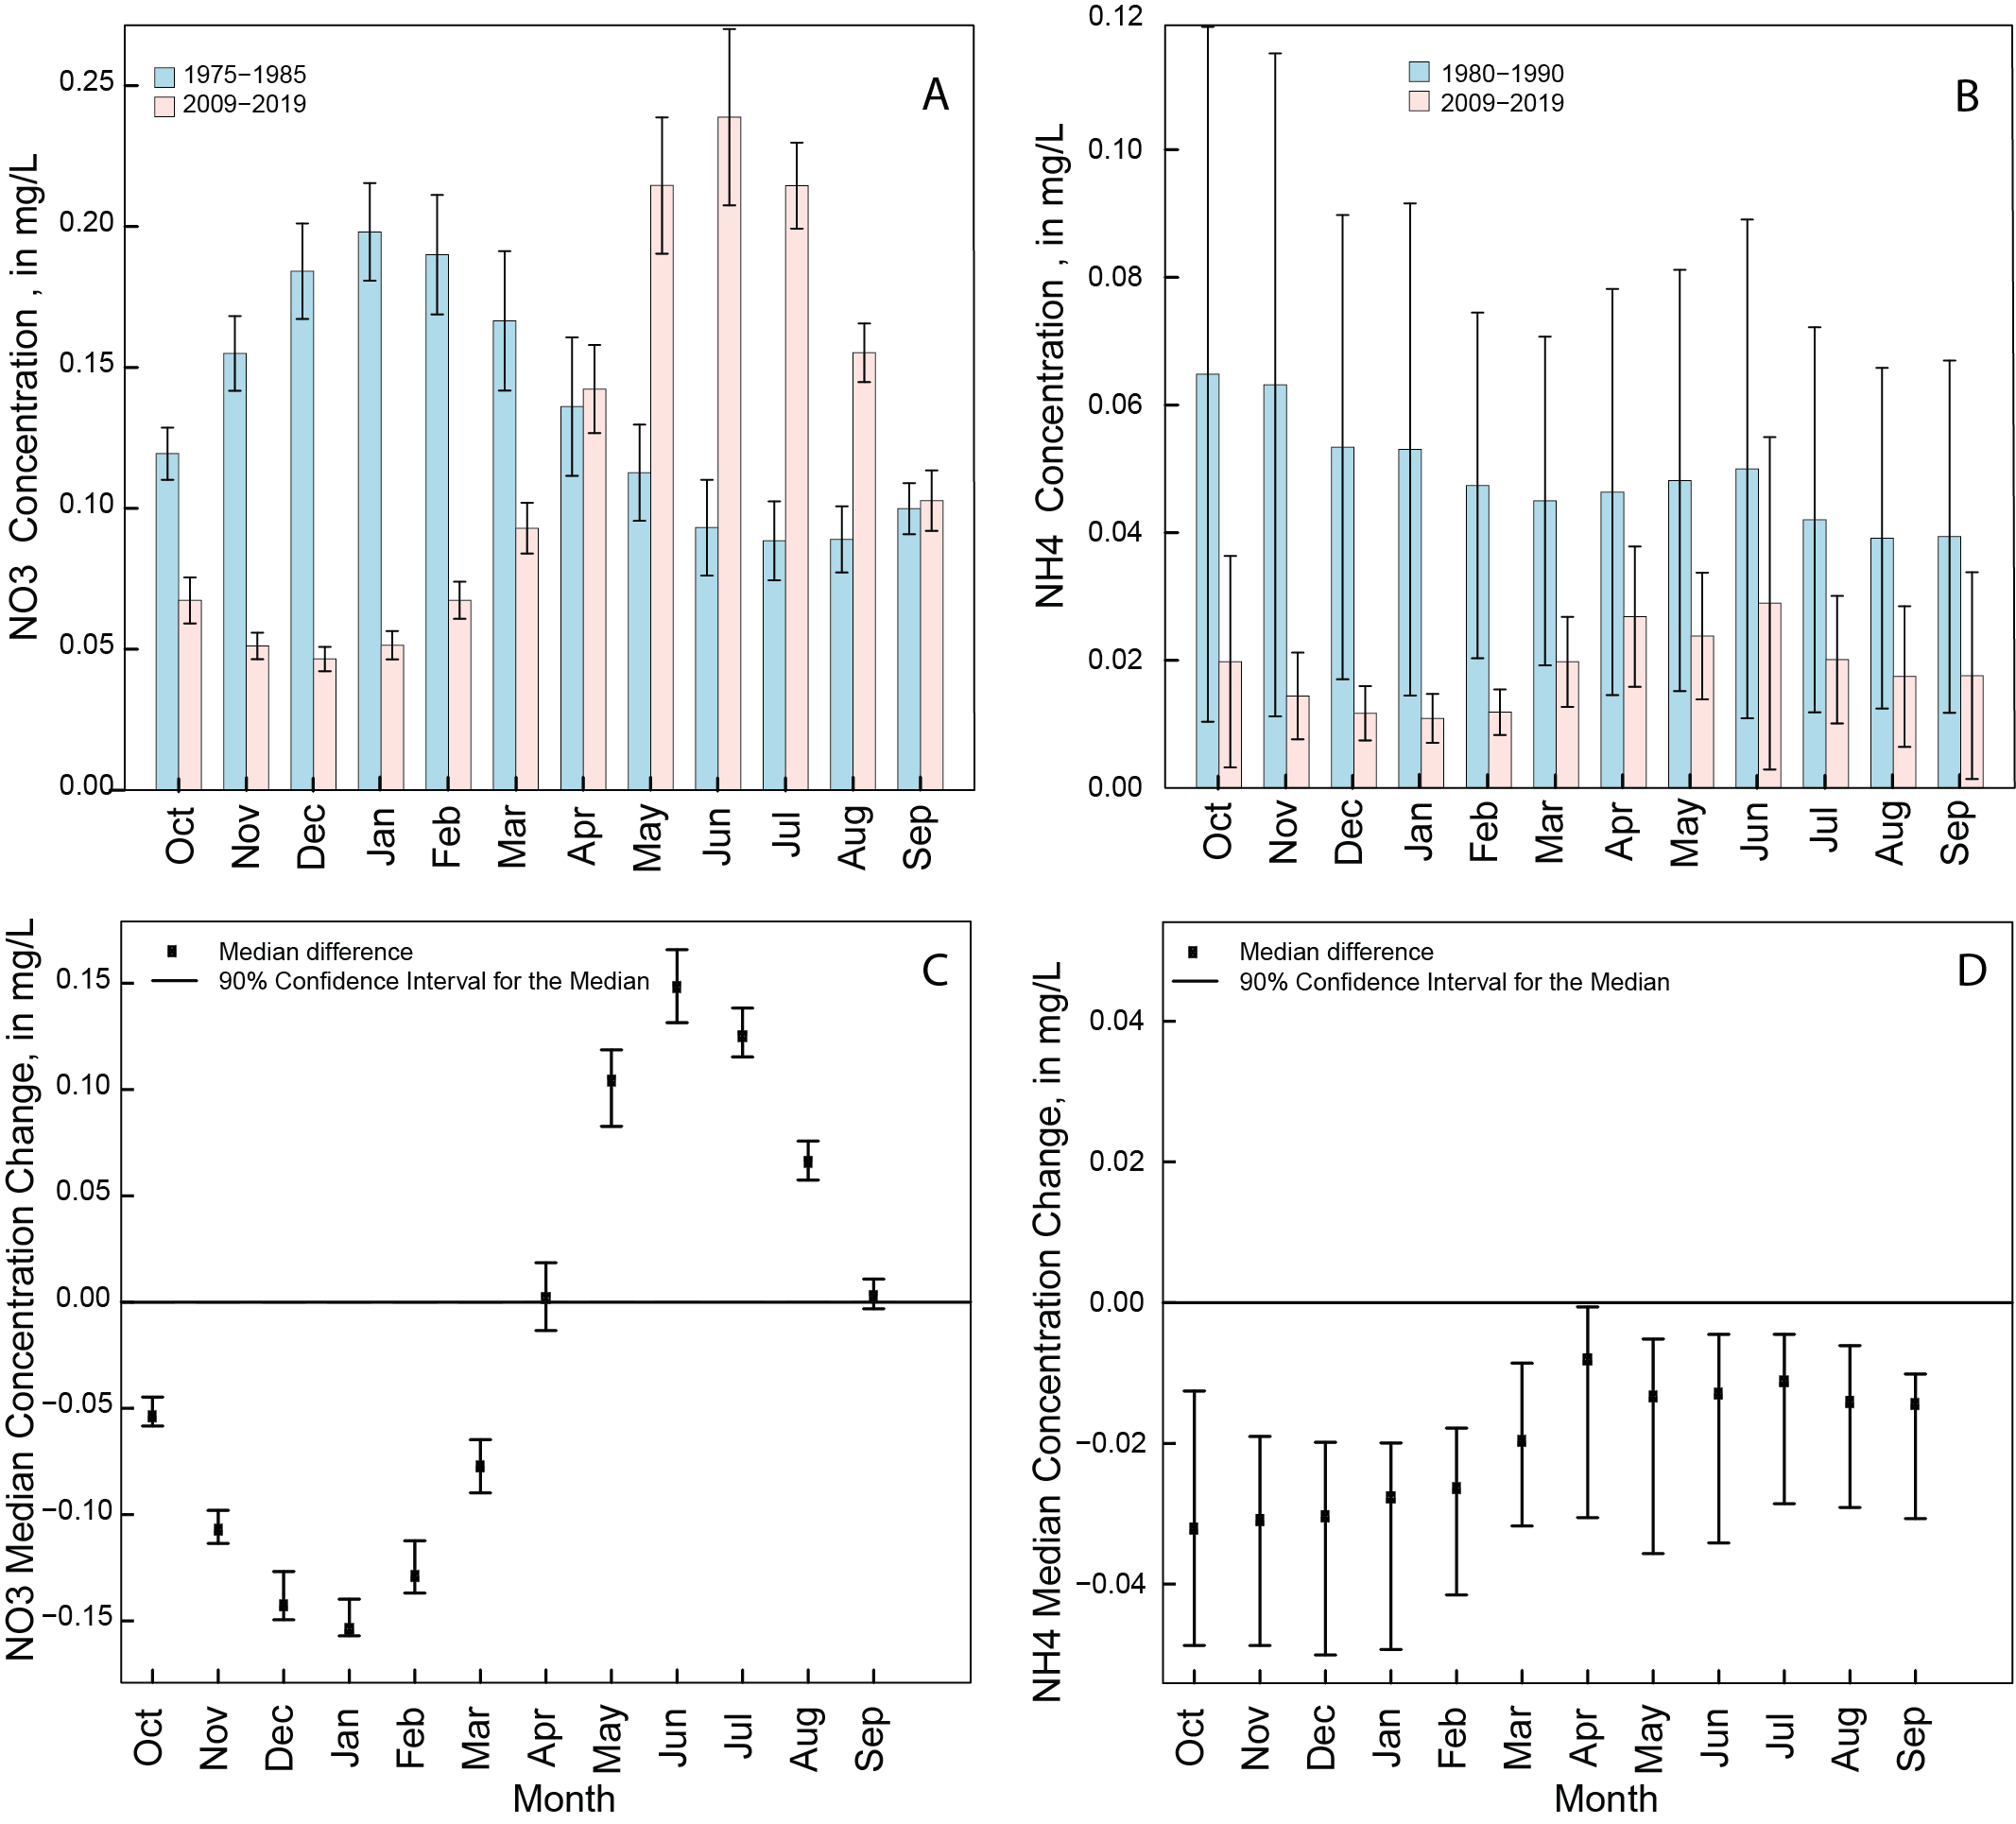

**Figure 6**. Sacramento River at Freeport monthly side by side bar plot showing concentration difference (A, nitrate) and (B, ammonium) between the early (1975-1985) and recent decade (2009-2019). Values are by water year. Monthly median concentration range difference for early and recent decade and 90% confidence intervals (C and D).

## **San Joaquin River near Vernalis, Nutrient Concentrations, Loads, and Trends**

WRTDS modeling results for the San Joaquin River near Vernalis are shown in Figure 7. Annually averaged flow-normalized nitrate concentrations varied with in the 1970-2019 period and were greatly affected by high variability in discharge (Figure 7A). Results of the EGRETci test indicated a “likely” decrease in concentration (about 0.14 mg-N/L) and loads (about 0.27 million kg-N/year) over the 1970-2019 period (Table 2). Figures 7A and 7B show that the width of the 90% confidence band for the flow normalized concentrations and loads were relatively the same throughout the 1970-2019 period. Results of the Mann-Whitney-Wilcoxon Rank Sum test show that in the early decade nitrate concentrations were highest in the winter. On the other hand, concentrations are highest during the summer in the recent decade (figure 8A). Median concentrations difference between the early and recent decade are only significant in the months of February and July through September (figure 8C).

Estimated annual concentrations and loads for ammonium show a different pattern than that of nitrate (figures 7C and 7D). Results show great variation in concentrations during the early time period 1975-1985 and for loads during 1985-1995 time. The ammonium concentrations decline starting in 1995 and continue to decline for the remainder of the period of record (figure 7C). Variation in estimated loads remain similar throughout the 1970-2019 period (figure 7D). There is a “highly likely” decrease in both concentration (about 0.11 mg-N/L) and loads (about 0.26 million kg-N/Year) over the 1970-2019 period (Table 2). Results from the Mann-Whitney-Wilcoxon Rank Sum test show that ammonium concentrations decrease in the recent (figure 8B). Unlike nitrate; the difference between the early and recent decade in ammonium concentrations are significant for all months of the year, with high ammonium concentrations in winter for the early decade and in summer for the recent decade (figures 8B and 8D).

Total Kjeldahl nitrogen concentrations and loads decreased continuously throughout the 1970-2019 period similar to that for ammonium (figures 7E, and 7F). Results from the EGRETci test also show that there is a “highly likely” decrease in TKN concentrations (about 0.78 mg-N/L) and a “very likely” decrease in loads (about 2.86 million kg-N/year) over the 1970-2019 period (Table 2).

Trends in OP concentrations and loads followed a similar pattern over the 1970-2019 period (figures 7G, and 7H). Results from the EGRETci test showed a “likely” decline in both concentrations and loads for the 1970-2019 period (about 0.01 mg-P/L in concentrations and 0.05 million kg/year in loads).

Trends in TP concentration and loads follow a similar pattern to that of OP with a greater variation in TP concentrations in the mid-80s reflected in the wide 90% confidence band (figure 7J). TP concentrations increased in the early decade to reach its highest value of 0.29 mg-P/L in 1988 followed by a continuance decrease in concentration though the remainder of the time period. Overall results from the EGRETci test show that there is a “highly likely” decline in TP concentrations about 0.09 mg-P/L and in loads about 0.16 million kg-P/year over the 1970-2019 period.

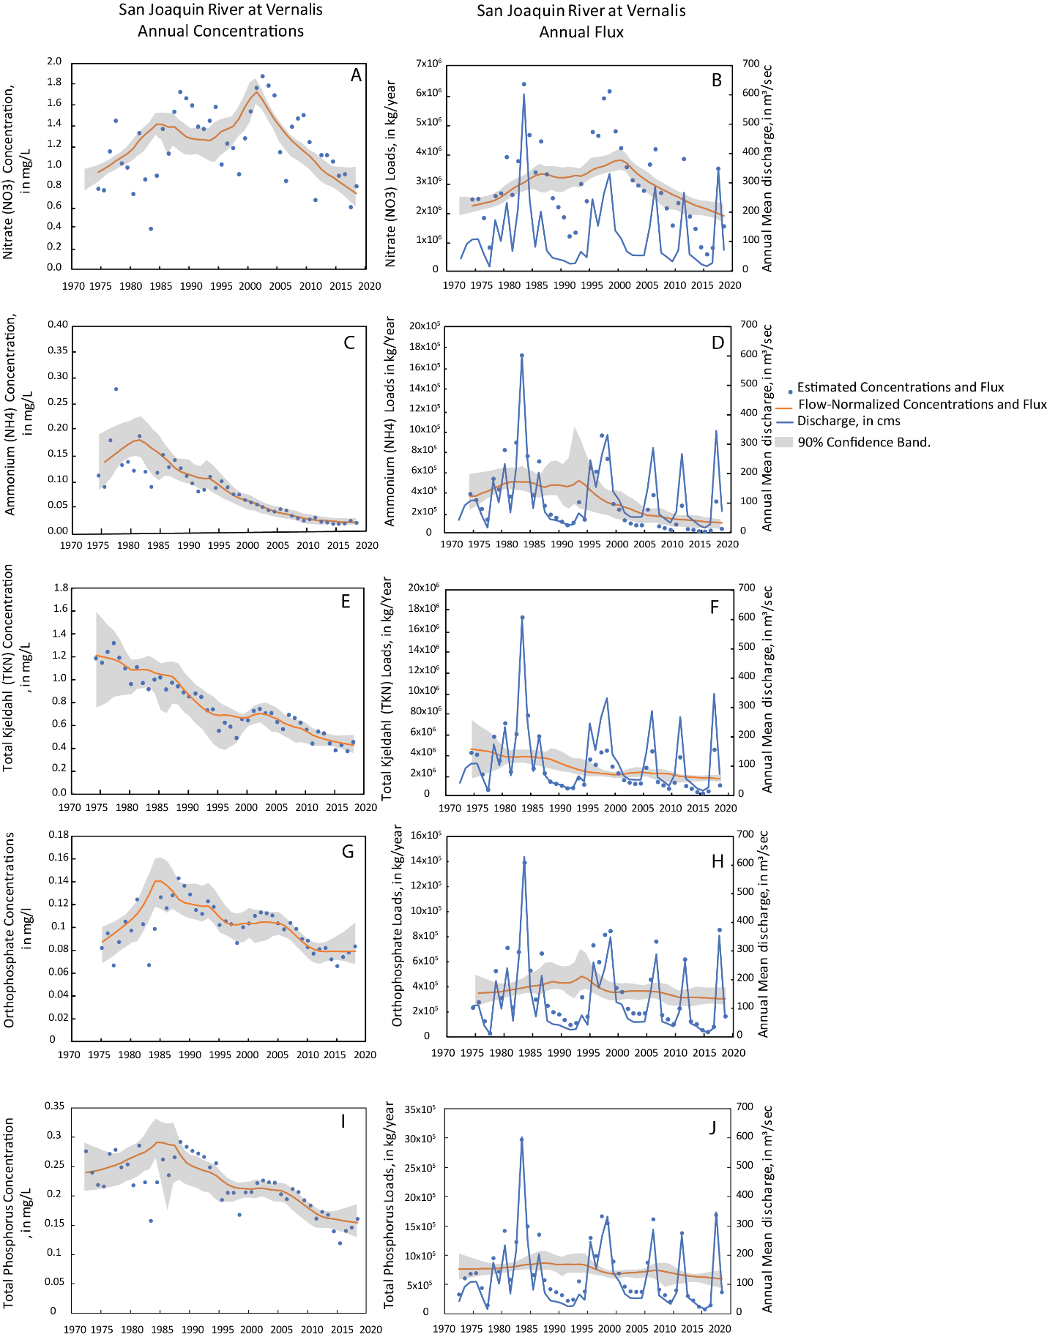

**Figure 7**. San Joaquin River at Vernalis models for nutrient concentrations and loads. with gray bands showing confidence bands. The blue dots are the modeled annual mean concentrations and loads. Solid blue line is discharge.

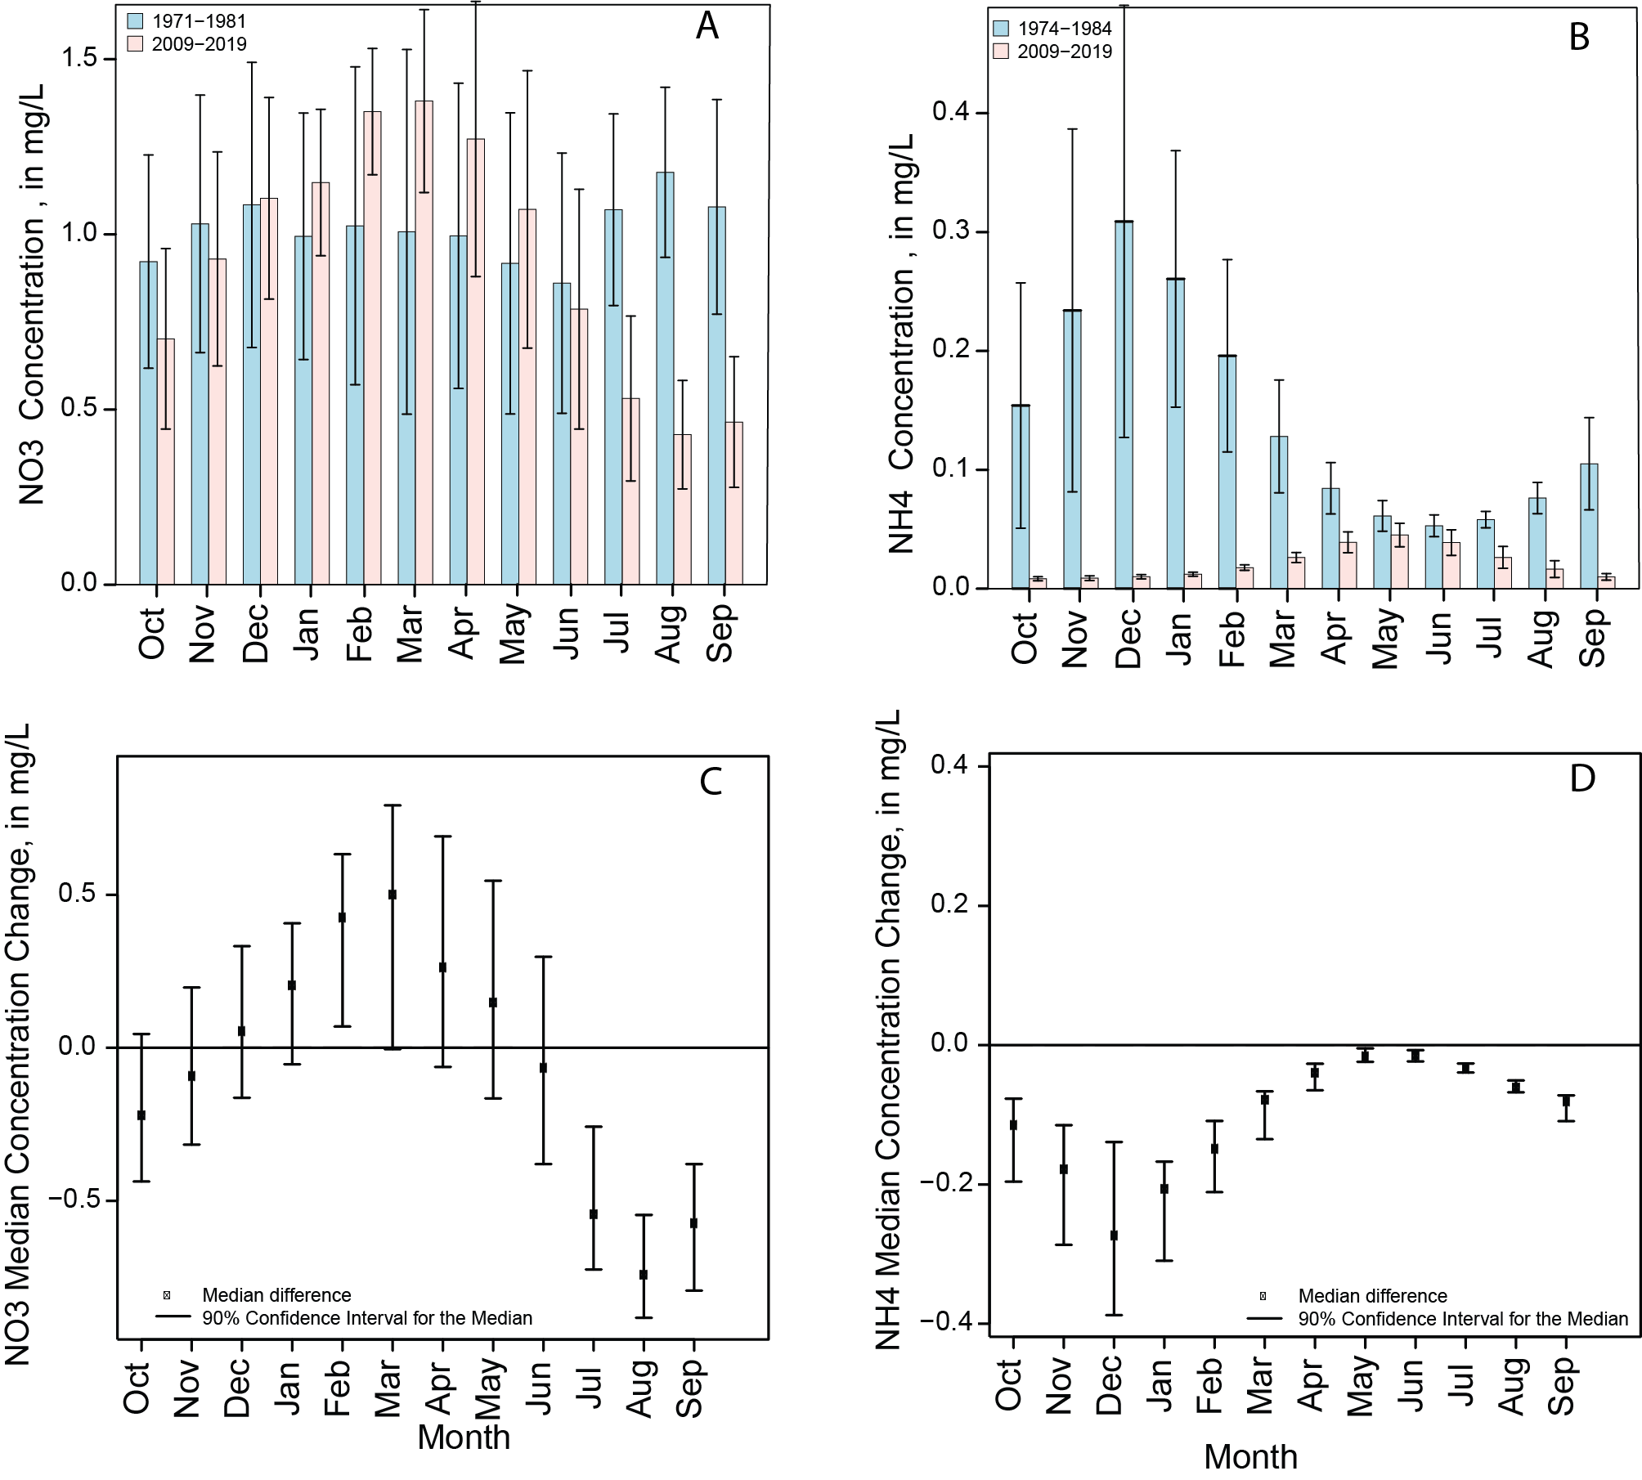

**Figure 6**. San Joaquin River near Vernalis monthly side by side bar plot showing concentration difference (A, nitrate) and (B, ammonium) between the early and recent decade. Monthly median concentration range difference for early and recent decade and 90% confidence intervals (C and D).

## **Nutrient Ratios**

Ratios of nitrate to ammonium have changed over the years at both the Sacramento River at Freeport and San Joaquin River near Vernalis. Time series plots for both locations showing micromolar concentrations and ratios of nitrate to ammonium are shown in Figure 9.

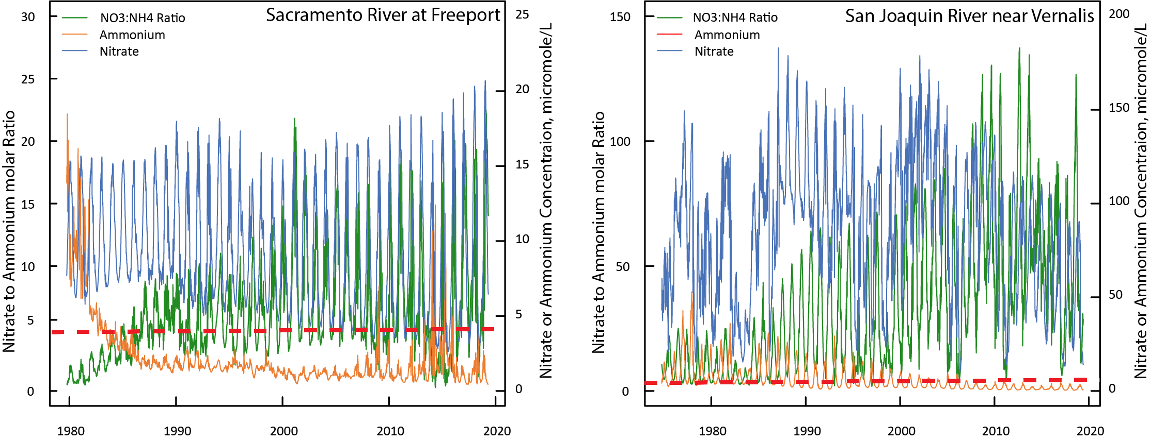

**Figure 9.** Time series plots of modeled daily nitrate to ammonium ratios and micromolar concentrations of nitrate and ammonium for the Sacramento River at Freeport and San Joaquin River near Vernalis sites. Red dashed line shows concentration of 0.056 mg-N/L (4 μM)for ammonium.

Both locations show increasing ratios of nitrate to ammonium, and decreasing concentrations of ammonium, for the period of record. The current nitrate to ammonium ratios are much higher at the San Joaquin River at Vernalis due to higher concentrations of nitrate in the water. The median amount of ammonium relative to nitrate at the Sacramento River site was 19% for the period of record, but current amounts (2019) are between 6% to 7%. In contrast the current relative amount of ammonium to nitrate (2019) in the San Joaquin River is between 3% to 4%.

It has been suggested that ammonium concentrations in excess of 0.4 μM can decrease primary productivity (Parker et al., 2012). In the early part of the record, ammonium concentrations exceeded 4 μM at the Sacramento River site until about 1985, and then were consistently less except for drought years such as 2014 and 2015 when concentrations were in excess of 4 μMdue to reverse flows of water IN THE Sacramento River and water from the wastewater treatment plant reaching the sampling location at Freeport. In contrast, ammonium concentrations exceeded 4 μM at the San Joaquin River until about 2004 when the concentrations decreased and remained below that level to the present. Nitrate concentrations in the San Joaquin are much higher than those of the Sacramento River and as a result, the nitrate to ammonium ratio is much higher.

Ratios of bioavailable nutrients have long been suggested as a means of determining which nutrient has the potential to limit primary productivity in aquatic ecosystems (Redfield, 1958). For marine ecosystems, it was suggested that an optimum molar ratio of bioavailable nitrogen to phosphorus in water is 16 to 1 (Redfield, 1958). Water with a ratio of less than 16 to 1 thus have the potentialto be nitrogen limited, while water with a higher ratio have the potential to be phosphorus limited. This was based on the nutrient stoichiometry of marine phytoplankton. Although this ratio may be appropriate to determine nutrient limitation in marine aquatic ecosystems, it has been suggested that freshwater streams where phytoplankton tend to have higher N requirements, may more likely have an optimum ratio of 24:1 (Maranger et al., 2011). As the wastewater treatment plant upgrades come online, the ratio of bioavailable nutrients within the Delta will change because of lower ammonium and nitrate inputs with little change in P inputs. The ratios determined just upstream in the Sacramento River at Freeport site provide a good indication of what to expect. Molar ratios of daily inorganic nitrogen (ammonium plus nitrate) to orthophosphate are shown in figure 10. The ratios differ at the Sacramento River and San Joaquin River sites. Nitrate, in particular, is much higher in the San Joaquin River relative to the Sacramento River. The plots show an annual cycle of ratios which are better seen as monthly boxplots in figure 11. The Sacramento River at Freeport site has a molar ratio that is mostly less than the ratio of 24:1 suggested by Maranger et al., 2011 and drops below 10 during the growing season indicating a higher potential for nitrogen limited water entering the Delta. In contrast, the San Joaquin River has generally higher molar ratios of nitrogen to phosphorus with more variability, indicating a higher potential for phosphorus limitation, with ratios that increase during the growing season, possibly due to runoff of nitrate rich water from the agricultural San Joaquin Valley. Since much of the San Joaquin River flow is diverted to the export pumps in the southern portion of the valley, the Sacramento River location is more indicative of what the nutrient ratios will be once the treatment plant upgrades are in place.

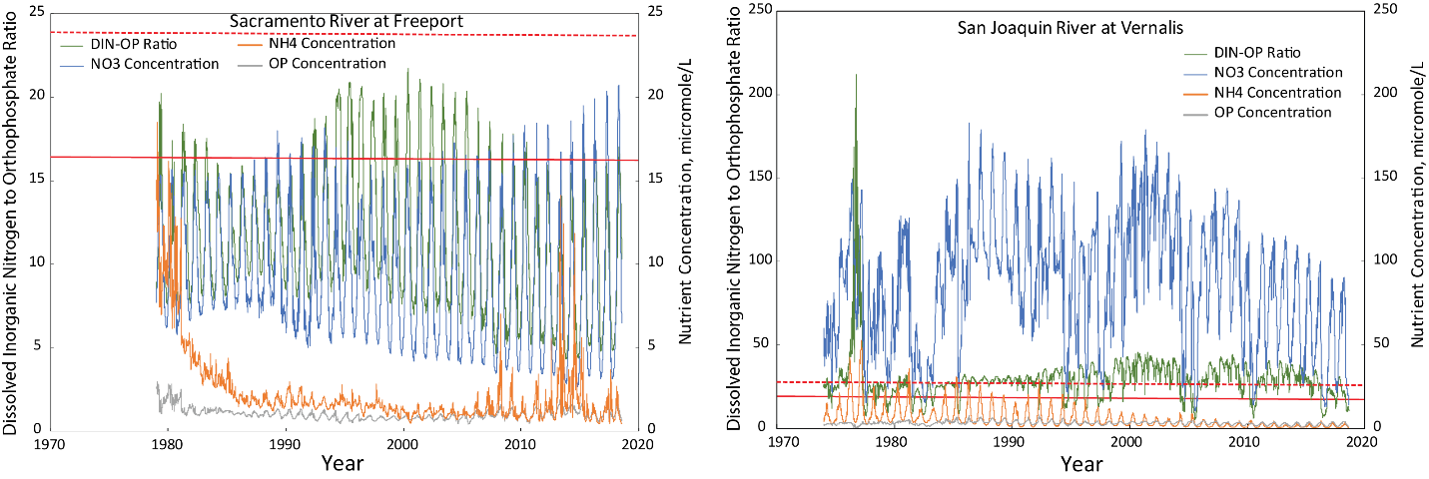

**Figure 10.** Modeled daily molar ratios of dissolved inorganic nitrogen (nitrate plus ammonium) to inorganic phosphorus (orthophosphate) for the Sacramento River at Freeport and San Joaquin River near Vernalis sites; and, nutrient concentrations (nitrate, ammonium and orthophosphate in micromoles per liter. Solid red line indicates Redfield N to P ratio (16N:1P). Dashed red line indicates possible ideal N to P ratio for freshwater streams (24N:1P)

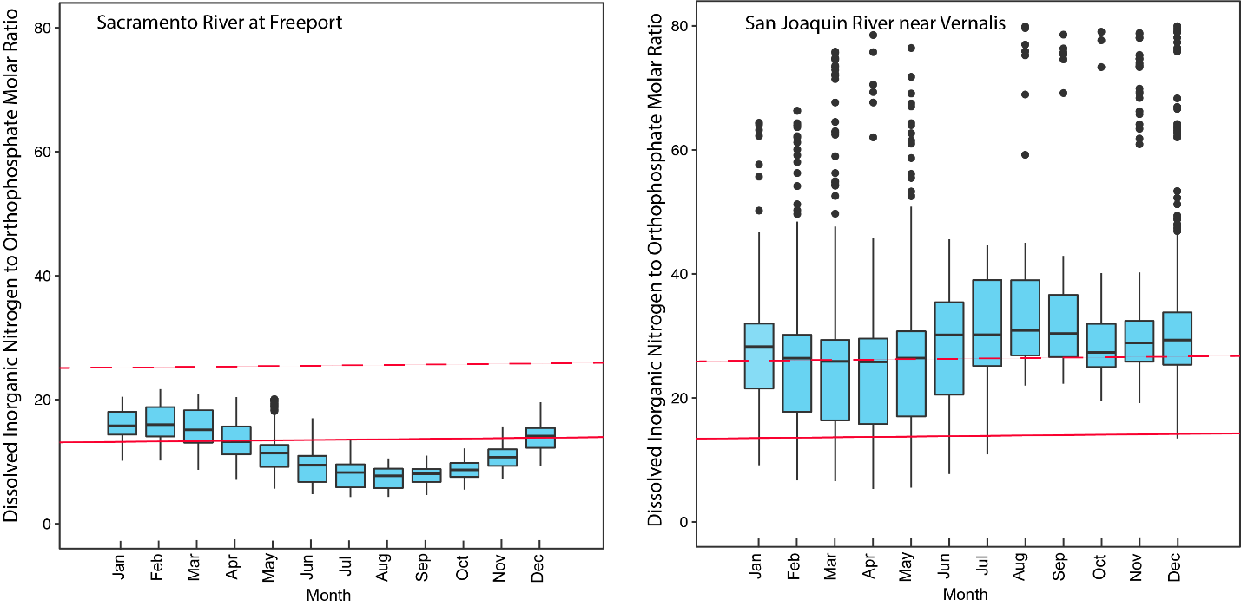**Figure 11.** Boxplots of molar ratios of dissolved inorganic nitrogen (nitrate plus ammonium) to orthophosphate for the Sacramento River at Freeport and San Joaquin River near Vernalis sites for XXX to YYY dates.

## **Nutrient Sources using SPARROW model**

The SPARROW (Wise et. al., 2020) model was used to quantify the amount of total nitrogen and total phosphorus delivered to the Delta from the upstream watershed and to identify major sources of TN and TP both on a watershed scale and on a cumulative scale along the course of the Sacramento River and the San Joaquin River. At the Sacramento River at Freeport, the SPARROW model estimated about 6.8 million kg/year of TN and 1.5 million kg/year of TP loads are delivered to the Delta. The model estimated that annually about 14% percent of the TN load and 35% percent of the TP loads to the Delta comes from Regional San effluent discharge to the Sacramento River. At the San Joaquin River near Vernalis location, the SPARROW model estimated about 3 million kg/year of TN and 0.5 million kg/year of TP loads are delivered to the Delta. The model estimated about 10% of the TN load and 19% percent of the TP loads originates from two upstream waste water facilities (Turlock and Modesto, Figure 1) effluent discharge.

Figure 12A shows the simulates delivered total nitrogen loads for each stream reach

(the incremental catchment loads plus those from all of the upstream catchments) of the Sacramento and San Joaquin Rivers draining to the Delta. Within the Sacramento River watershed, the model identified major sources of total nitrogen as; 40% from fertilizer and manure applied to agricultural areas within the central valley (Figure 12B), 32% from atmospheric deposition, 14% from point sources from waste water treatment facilities, 8% from scrub and grass land, and 6% from urban developed land (Figure 12B). Within the San Joaquin River watershed, the model identified major sources of total nitrogen as; 65% from fertilizer and manure, 17% from atmospheric deposition, 10% from waste water treatment facilities, 5% from scrub and grass land, and 3% from urban runoff (Figure 12B).

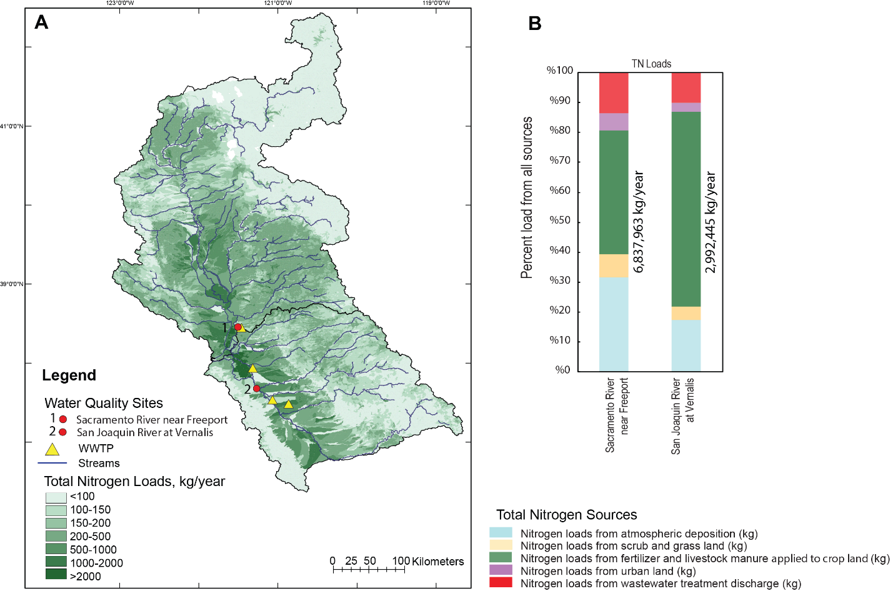

**Figure 12**: A) Total Nitrogen (TN) Load Exported from Catchments in kg-N/year.

B) Graph shows percent of incremental TN load from all sources in each watershed. What years of data are these for?

Along the 600 km length of the Sacramento River extending from XX to YY, sources of TN vary. In the headwaters atmospheric deposition is the main source. As the water moves through the Central Valley sources change and loads from fertilizer and livestock manure applications increase at about 150 km from the mouth due to discharges from the Colusa Basin Drain and the Feather River. Downstream of the Sacramento River at Freeport site, TN from point sources increases due to discharges from Regional San wastewater treatment plant (figure 13A). In the headwaters of the San Joaquin River, atmospheric deposition is the main source of total nitrogen and then fertilizer and livestock manure applied to agricultural lands is the major source once the river enters the Central Valley. TN loads from point sources increase at about 150 km from the mouth due to discharge from waste water treatment facilities in the cities of Turlock and Modesto and increase at about 66 km from the mouth due to discharge inputs from the Stockton waste water treatment facility (Figure 13B).

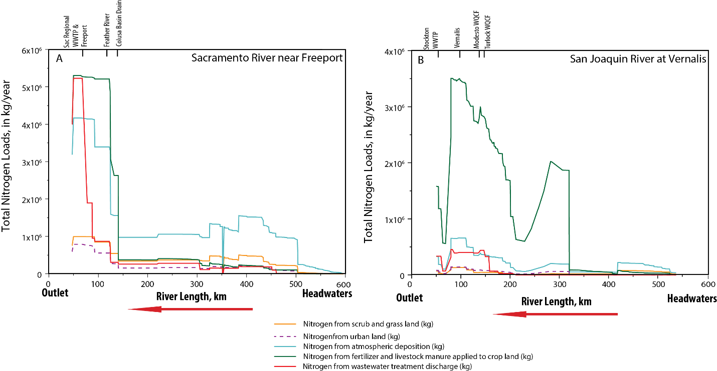

**Figure 13.** Annual? nitrogen loads from various sources in kilograms upstream of the (A)Sacramento River at Freeport and (B) the San Joaquin River near Vernalis. What years of data?

Figure 14A shows the simulates delivered total phosphorus loads for each stream reach

(the incremental catchment loads plus those from all of the upstream catchments) of the Sacramento and San Joaquin Rivers draining to the Delta. The SPARROW model identified major sources of TP in the Sacramento River watershed as 46% from agricultural activities (from fertilizer and manure applications to agricultural lands within the Central Valley), 35% from wastewater treatment discharges, 13% from geologic phosphorus from the stream channel and upland areas, and 7% from urban runoff around the (Figure 14B). In the San Joaquin River watershed, most TP load (73%) originates from agricultural land attributed to fertilizer and manure applications, 20% from wastewater treatment facilities, 6% from geologic phosphorus from the stream channel and upland areas, and 2% from urban runoff (Figure 14B).

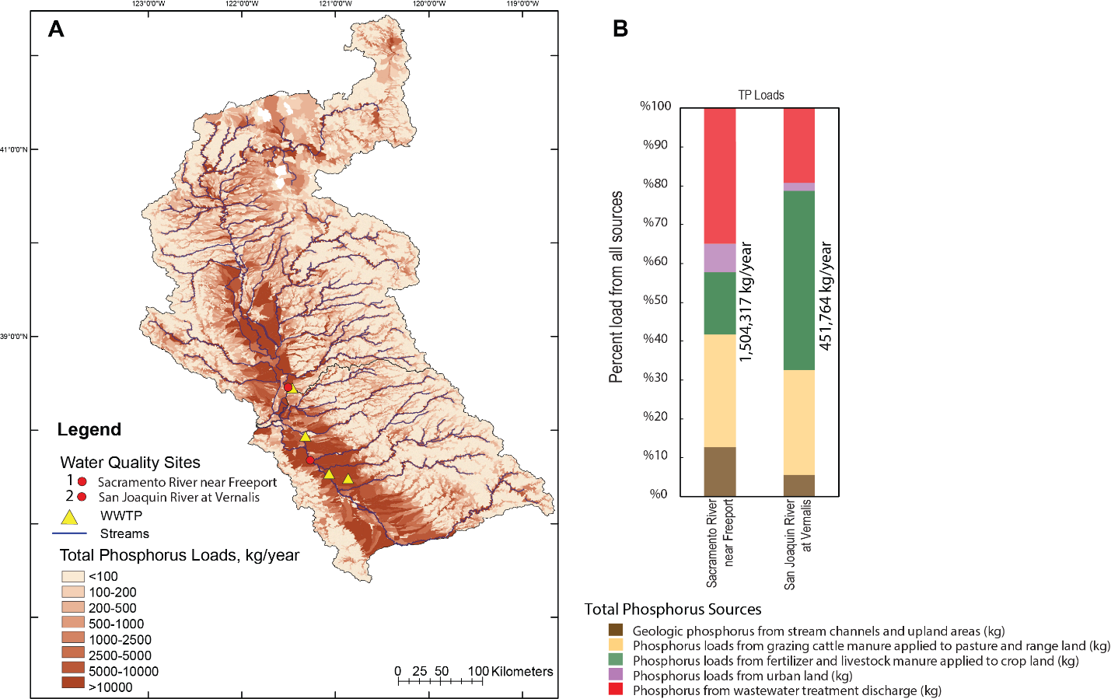

**Figure 14**. A) Total Phosphorus (TP) Load Exported from Catchments in kg/year.

B) Graph shows percent of incremental TN load from all sources in each watershed.

Along the course of the Sacramento River, agricultural activity (from applied fertilizer and manure) account for most of the TP loads from the headwaters through the central valley till about 70 km from the mouth when discharges from the Regional San wastewater treatment plant result in an increase in TP load (figure 15A). In the San Joaquin River watershed, agricultural activity also accounts for most of the TP load along the course of the river. TP loads from point sources increase with the discharges from the Turlock and Modesto waste water facilities, and from Stockton further downstream (figure 15B).

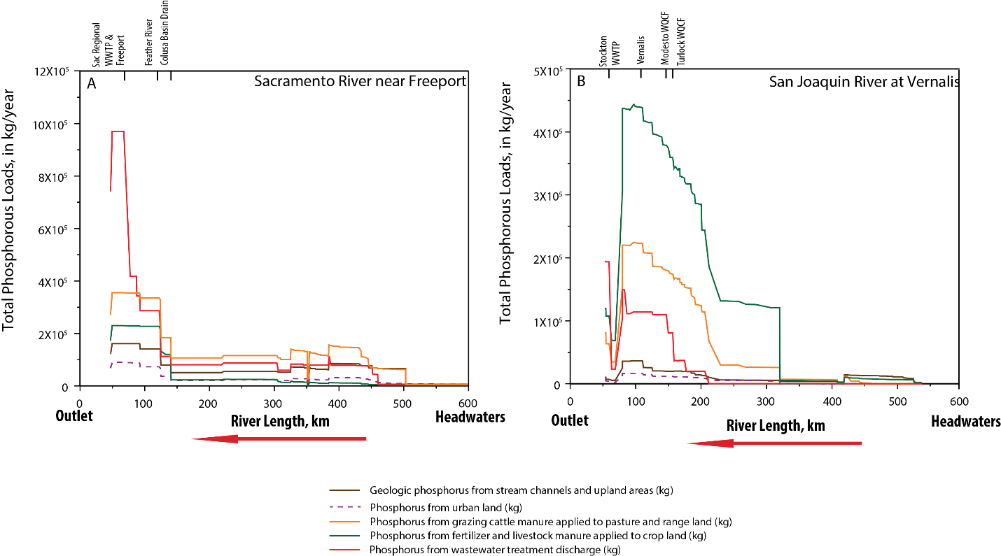

**Figure 15**. Phosphorus loads from various sources in kilograms upstream of (A) the Sacramento River at Freeport and (B) the San Joaquin River near Vernalis.

## **Comparison of Estimated Loads from Models and Continuous Monitoring**

Models such as WRTDS rely on discrete samples which need to be collected throughout the year and throughout the range of flow conditions. The WRTDS models used here had a sufficient number (n=XX) and temporal distribution (Figure X) of discrete samples to produce results with low bias, but it is generally impossible to have a sufficient number of discrete samples to adequately characterize the full range of concentrations over all flow conditions (Pellerin et al., 2014). However, in situ water quality sensors be used to collect data continuously and at high sampling frequency. An in situ nitrate sensor that records nitrate concentration data every 15-minutes has been deployed at the Sacramento River at Freeport site since 2013. A comparison plot of nitrate measured by the sensor and the modeled concentrations of nitrate using WRTDS/EGRET Model is shown in Figure 16A, along with Sacramento River discharge also measured at Freeport at 15-minute intervals (Figure 16B). It is evident from Figure 16A that the EGRET model did not capture the higher nitrate concentration events which were mostly associated with winter runoff events. Discharge and load calculations based on the available in situ data at this site for the period of time of sensor deployment are shown in Figure 16B.

Peak nitrate concentrations generally occur before peak discharge, indicating that dilution lowers concentration. The modeled nitrate concentrations from WRTDS match up well with the in-situ sensor measurements, but obviously miss the peaks in concentration. The nitrate sensor had down periods of time so annual load calculations cannot always be made. In particular, the sensor was not recording nitrate during the high flow period in 2017 when discharge was the highest for the period of record. Comparisons of annual load between X and Y could thus only be made for three water years: 2014, 2015, and 2016. The WRTDS calculated nitrate-N load for water year 2014 was slightly higher than the in situ data (873,026 kg for WRTDS and 858,319 kg-N for the sensor). The WRTDS estimate of nitrate-N load was lower in water years 2015 and 2016. In 2015, the WRTDS estimate was 1,400,923 kg while the sensor estimate was 2,057,506 kg a X% difference. In 2016, the WRTDS estimate was 2,255,313 kg and the sensor estimate was 2,996,616 kg. For the available record, annual? sensor measured loads were between 98 to 146% of the estimated WRTDS loads. The higher loads measured with the sensor are consistent with the fact that discrete sampling cannot always measure the highest concentrations, especially with infrequent sampling.

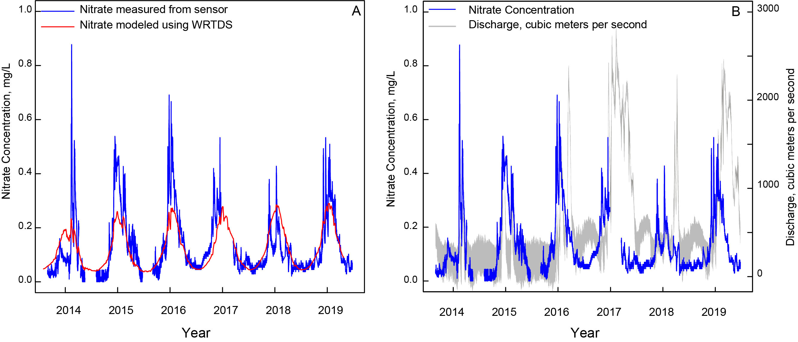

**Figure 16**. Comparison of nitrate measurements made by an in situ continuous (15-minute) sensor and nitrate concentrations modeled with WRTDS using discrete data collected as indicated by the XX symbols (A) and nitrate concentrations made by a sensor with continuous discharge (B); Nitrate sensor and discharge measurements are at 15 minute intervals.

## **DISCUSSION AND CONCLUSIONS**

Nutrient loading to the Delta will undergo a change once planned upgrades to the Sacramento Regional Sanitation District facility are completed. Source modeling using SPARROW indicates that about 14% of the total nitrogen entering the Delta just downstream from the Sacramento River at Freeport originates from the wastewater treatment. The upstream sources modeled by SPARROW include all forms of nitrogen including dissolved and particulate organic nitrogen whereas the treatment plant effluent discharges nitrogen mainly in the form of ammonium. Although ammonium is considered a nutrient for primary productivity, estuarine concentrations above 4 uM have been purported to negatively impact primary productivity (REFS). The amount of nitrogen currently discharged in the upper part of the Delta from wastewater treatment provides a year round source of bioavailable nitrogen which probably maintains the upper part of the estuary as a phosphorus limited system with regard to primary productivity. The decrease in nitrogen load after treatment plant upgrades has the potential to cause a shift in which nutrient limits primary productivity. Modeled daily molar concentrations of dissolved inorganic nitrogen and orthophosphate show ratios of bioavailable nitrogen to bioavailable phosphorus of about 18 to 20 entering during spring with declining median ratios in the summer about 10, suggesting a nitrogen limited system during the summer for the northern portion of the Delta. In contrast, molar ratios of bioavailable nitrogen to bioavailable phosphorus from the San Joaquin River are elevated throughout the year (figure 11) with median values in excess of 25 which increase to over 30 during the summer. The difference between the two rivers is driven by higher nitrate concentrations in the San Joaquin River relative to the Sacramento River. Therefore, the northern portion of the Delta will receive nitrogen limited water in the summer from the Sacramento River while the southern portion of the Delta will receive phosphorus limited water from the San Joaquin River. Trends in ammonium concentrations and loads decreased at both river sites, especially in the early part of the study period for the Sacramento River and more gradually at the San Joaquin. Modeling of these concentrations indicate that both rivers will have ammonium concentrations below 4 uM after the treatment plant upgrade as the rivers enter the Delta.

Flow normalized concentrations and loads of other nutrients show generally stable conditions after initial declines. There was a statistically significant increase in nitrate concentration and load for the Sacramento River site in the early part of the record and all other nutrients showed statistically significant decreases mainly in the early part of the record and stable conditions after 2000. Unless conditions change with regard to land use or climate, these stable flow normalized conditions may be what to expect in future years. Modeling nutrient concentrations and load with WRTDS provides statistically valid information on concentrations, loads, and trends, but utilizes discrete water quality data collected at infrequent intervals for calibration, which, at best, might be weekly intervals. A period of 20 years is considered minimum for producing valid models. The infrequent sampling results in missing of concentration highs, especially during a runoff season. In situ sensors can greatly increase the amount of data collected but also require considerable maintenance and portions of a continuous record will be missed when a sensor is down. The nitrate sensor deployed at Freeport demonstrates how peak concentrations happen during the start of a runoff period and then become diluted with sustained high river flows, such as the recent post drought years (Figure 16).

As wastewater sources of dissolved inorganic nitrogen diminish, upstream watershed sources of nitrogen will become the main loading contributor to the Delta. Source modeling using SPARROW indicates that agricultural activities and atmospheric deposition will be the two main sources after XXX happens. The Central Valley is the largest contributor to agriculturally derived nitrogen whereas the surrounding land cover of the Coast Ranges and Sierra Nevada are the primary contributors to atmospheric loading. Within the San Joaquin River watershed, agricultural activities are the main contributor of nitrogen to the Delta. Nitrate concentrations increase in the summer months due to agricultural runoff and result in an increase in the dissolved inorganic nitrogen to orthophosphate ratio. The effects on the Delta food web cannot be predicted through this analysis, but further monitoring will be necessary to understand how phytoplankton primary productivity responds to these changes.

# **REFERENCES**

ADD:

Cooke et al report;

Richey et al workshop memo

Senn et al report (in press)

Alexander R, Smith RA, Schwarz GE, Boyer EW, Nolan JV, Brakebill JW. 2008. Differences in Phosphorus and Nitrogen Delivery to the Gulf of Mexico from the Mississippi River Basin. Journal of Environmental Science and Technology 42(3):822-830.

Beck MW, Jabusch TW, Trowbridge PR, Senn DB. 2018. Four decades of water quality change in the upper San Francisco Estuary, Estuarine Coastal and Shelf Science 212:11-22. doi: <https://doi.org/10.1016/j.ecss.2018.06.021>.

CA. Gov Delta Protection Commission. 2012. Economic Sustainability Plan for the

Sacramento-San Joaquin Delta. Available from: <https://www.delta.ca.gov/files/2016/10/Final_ESP_w_Appendices_2012.pdf>

Domagalski J, Saleh D. 2015. Sources and Transport of Phosphorus to Rivers in California and Adjacent States, U.S., as Determined by SPARROW Modeling. Journal of the American Water Resources Association (JAWRA) 1-24. doi: https://doi.org/10.1111/1752-1688.12326.

Fishman MJ. 1993. Methods of Analysis by the U.S. Geological Survey National Water Quality Laboratory, Determination of Inorganic and Organic Constituents in Water and Fluvial Sediments, Open- File Report 93-125. Reston. VA. U.S. Geological Survey. Available from: http://pubs.er.usgs.gov/usgspubs/ofr/ofr93125.

Glibert PM. 2010. Long-Term Changes in Nutrient Loading and Stoichiometry and Their Relationships with Changes in the Food Web and Dominant Pelagic Fish Species in the San Francisco Estuary. California. Reviews in Fisheries Science 18:2, 211-232.

Hirsch RM, Archifield SA, De Cicco LD. 2015. A bootstrap method for estimating uncertainty of water quality trends. Environ Modell Softw 73:148–166 doi: <https://doi.org/10.1016/j.envsoft.2015.07.017>.

Hirsch RM, Moyer DL, Archfield SA. 2010. Weighted regressions on time, discharge, and season (WRTDS), with an application to Chesapeake Bay river inputs: J Am Water Resour Assoc 46:857–880. doi: http://dx.doi.org/10.1111/j.1752-1688.2010.00482.x

Jassby AD, Cloern JE, Cole BE. 2002. Annual Primary Production: Patterns and Mechanisms of Change in a Nutrient-Rich Tidal Ecosystem. Limnology and Oceanography 47(3):698-712.

Jassby AD, Cloern JE 2000. Organic Matter Sources and Rehabilitation of the Sacramento-San Joaquin Delta (California, USA). Aquatic Conservation: Marine and Freshwater Ecosystems 10:323-352.

Kraus TEC, O’Donnell KO, Downing BD, Burau JR, Bergamaschi BA. 2017. Using Paired In Situ High Frequency Nitrate Measurements to Better Understand Controls on Nitrate Concentrations and Estimate Nitrification Rates in a Wastewater-Impacted River, Water Resources Research. 53, 8423–8442. doi: <http://doi.org/10.1002/2017WR020670>.

Kratzer CR, Kent RH, Saleh DK, Knifong DL, Dileanis PD, Orlando JL. 2011. Trends in nutrient concentrations, loads, and yields in streams in the Sacramento, San Joaquin, and Santa Ana Basins, California, 1975–2004: U.S. Geological Survey Scientific Investigations Report 2010-5228, 112 pp.

Krich-Brinton A. 2017. Projected Nutrient Load Reductions to the Sacramento-San Joaquin Delta Associated with Changes at Four POTWs. Larry Walker Associates, Memorandum. Availablefrom:<https://www.waterboards.ca.gov/centralvalley/water_issues/delta_water_quality/delta_nutrient_research_plan/public_involvement_stag_meetings/2017_0417_massbal_memo.pdf>

Luoma SN, Dahm CN, Healy M, Moore JN. 2015. Challenges Facing the Sacramento—San Joaquin Delta: Complex, Chaotic, or Simply Cantakerous, San Francisco Estuary and Watershed Science. 13: 3 article 7. doi: http://doi.org/10.15447/sfews.2015v13iss3art7

Novick E, Holleman R, Jabusch T, Sun J, Trowbridge P, Senn D, Guerin M, Kendall C, Young M, Peek S. 2015. Characterizing and Quantifying Nutrient Sources, Sinks and Transformations in the Delta: Synthesis, Modeling and Recommendations for Monitoring, December 2015. San Francisco Estuary Institute.

Parker AE, Dugdale RC, Wilkerson FP. 2012. Elevated ammonium concentrations from wastewater discharge depress primary productivity in the Sacramento River and the Northern San Francisco Estuary. Marine Pollution Bulletin. 64: 574-586.

Pellerin BA, Bergamaschi BA, Gilliom RJ, Crawford CG, Saraceno J, Paul Frederick C, Downing, BD, Murphy JC. 2014. Mississippi River Nitrate Loads from High Frequency Sensor Measurements and Regression-Based Load Estimation, Environmental Science and Technology. 48:12612-12619. doi: https://doi.org/10.1021/es504029c.

Redfield AC. 1958. The Biological Control of Chemical Factors in the Environment. American Science, 46:205-221.

Richey A, Robinson A, Senn D. 2018. Operation Baseline Science and Monitoring Needs—A memorandum summarizing the outcomes of a stakeholder workshop and surveys. Available from: <https://sfbaynutrients.sfei.org/sites/default/files/final_regional_san_workshop_memo_10.03.2018.pdf>

Preston SD, Alexander RB, Schwarz GE, Crawford CG. 2011a. Factors Affecting Stream Nutrient Loads: A Synthesis of Regional SPARROW Model Results for the Continental United States. Journal of the American Water Resources Association 47(5):891-915. doi: https://doi.org/10.1111 ⁄ j.1752-1688.2011.00577.x.

Preston SD, Alexander RB, Woodside MD, Hamilton PA. 2009. SPARROW MODELING – Enhancing Understanding of the Nation’s Water Quality. U.S. Geological Survey Fact Sheet 2009-3019. 6 p. Available from: http://pubs.usgs.gov/fs/2009/3019/.

Saleh D, Domagalski J. 2015. SPARROW Modeling of Nitrogen Sources and Transport in Rivers and Streams of California and Adjacent States, U.S. Journal of the American Water Resources Association (JAWRA) 1-21. doi: https://doi.org/10.1111/1752-1688.12325.

Saleh DK, Domagalski JL, Kratzer CR, Knifong DL. 2003. Organic Carbon Trends, Loads, and Yields to the Sacramento-San Joaquin Delta, California, Water Years 1980 to 2000. U.S. Geological Survey Scientific Investigations Report 2003-4070. 77p. doi: <https://doi.org/10.3133/wri20034070>.

Sauer VB, Turnipseed DP. 2010. Stage Measurement at Gaging Stations. U.S. Geological Survey Techniques and Methods Book 3, Chap. A7. 45 pp.

Schlegel B, Domagalski JL. 2015. Riverine Nutrient Trends in the Sacramento and San Joaquin Basins, California: A Comparison to State and Regional Water Quality Policies, San Francisco Estuary and Watershed Science. 13: 4, Article 2.

Schwarz GE, Hoos AB, Alexander RB, Smith RA. 2006. The SPARROW Surface Water-Quality Model—Theory, Applications and User Documentation. U.S. Geological Survey Techniques and Methods. book 6. chap. B3. 248 p. and CD-ROM.

Templin WE, Cherry DE. 1997. Drainage-Return, Surface-Water Withdrawal, and Land-Use Data for the Sacramento–San Joaquin Delta, with Emphasis on Twitchell Island, California. U.S. Geological Survey Open-File Report 97-350. 31 p.

Turnipseed DP, Sauer VB. 2010. Discharge Measurements at Gaging Stations. Reston, VA. U.S. Geological Survey Techniques and Methods book 3, chap. A8. p. 87.

Western Regional Climate Center. Available from: <https://www.wrcc.dri.edu/cg-bin/cliMONtpre.pl?ca7630>

Wise et al., 2020, Sparrow model—when available

Yost. West Yost Associates. 2011. Wastewater Control Measures Study. Available from:

http://www.waterboards.ca.gov/centralvalley/water_issues/drinking_water_policy/dwp_wastewtr_cntrl_meas_stdy.pdf